Dharshini – 2021103520

Cholan – 2021103739

Rajalakshmi S - 2021103038

EMPLOYEE MANAGEMENT SYSTEM

CS6308- JAVA MINI PROJECT

DONE BY- TEAM NUMBER 15

Dharshini M

2024

**TABLE OF CONTENTS**

|  |  |  |
| --- | --- | --- |
| **S. No.** | **Topic** | **Page No.** |
| 1 | Abstract | 3 |
| 2 | Problem definition | 3 |
| 3 | Software description | 4 |
| 4 | Program Code | 5 |
| 5 | Output | 9 |

**Abstract:**

The Employee Management System (EMS) is a comprehensive software solution designed to streamline and automate the management of employees within an organization. The system provides a user-friendly interface that allows administrators to perform various tasks, including login, adding, deleting, viewing, and updating employee information.

The EMS enables administrators to securely log in to the system using authentication mechanisms to ensure data confidentiality. Once logged in, administrators can easily add new employees to the system by entering relevant details such as name, employee ID, position, and contact information.

In addition to adding new employees, the EMS also allows administrators to delete, view, and update existing employee records. This functionality enables administrators to maintain an up-to-date database of employee information, ensuring accuracy and efficiency in employee management.

Overall, the Employee Management System is a valuable tool for organizations looking to streamline their employee management processes. Its user-friendly interface and comprehensive features make it an ideal solution for organizations of all sizes.

**Problem Statement:**

Inefficient management of employee records and information can lead to various challenges for organizations, including data inaccuracies, time-consuming administrative tasks, and lack of centralized access to employee information. To address these challenges, there is a need for a comprehensive Employee Management System (EMS) that enables administrators to efficiently manage employee records, including adding, deleting, viewing, and updating employee information, while ensuring data security and accessibility. The key issues to be addressed by the EMS include inefficient record management, limited accessibility to employee information, data security concerns, administrative burden, and scalability. The development of an EMS aims to provide a centralized, user-friendly platform for managing employee records, enabling administrators to efficiently manage employee information while ensuring data security and accessibility.

**Software Description:**

1. NetBeans IDE: NetBeans IDE is a free, open-source integrated development environment (IDE) that enables developers to create applications in Java, JavaScript, HTML5, PHP, C/C++, and more. It provides tools for developing desktop, mobile, and web applications, as well as support for version control systems and project management. NetBeans features a smart code editor, code templates, and a powerful debugger, making it a comprehensive tool for software development.

2. JDK 21: JDK 21, or Java Development Kit 21, is the latest version of the official development kit for the Java programming language. It includes the Java Runtime Environment (JRE), Java Virtual Machine (JVM), and tools such as the Java compiler and debugger. JDK 21 provides developers with the tools they need to develop, debug, and deploy Java applications, and it is essential for building Java-based applications using NetBeans IDE.

3. MySQL: MySQL is a popular open-source relational database management system (RDBMS) that is widely used for building scalable, high-performance web applications. It is known for its reliability, ease of use, and strong performance. MySQL is compatible with various operating systems and programming languages, making it a versatile choice for developers. It supports SQL (Structured Query Language) for querying and managing data, and it can be integrated with other software, including NetBeans IDE, for seamless application development.

Together, NetBeans IDE, JDK 21, and MySQL provide a powerful environment for developing Java applications, offering developers the tools they need to create robust, scalable software solutions.

## Program Code:

## 

Figure 1: This is the code for the front page

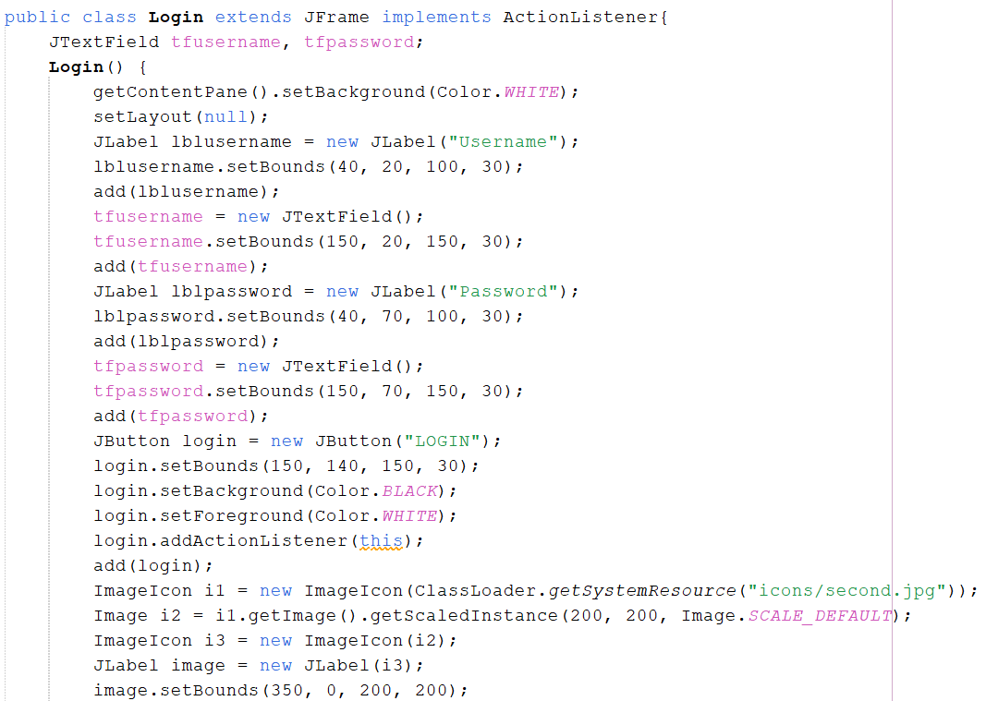Figure 2: This is the code for the login page for the admin

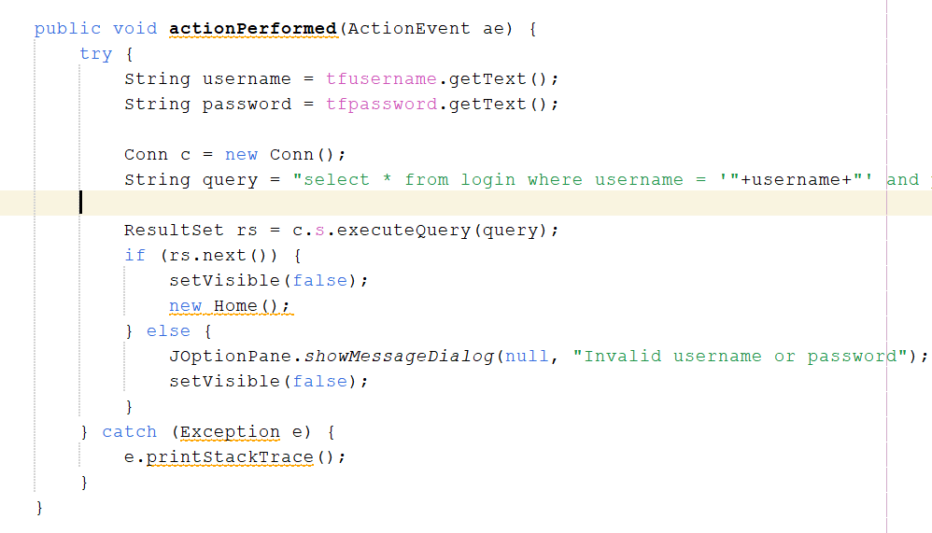Figure 3: Logic behind Login

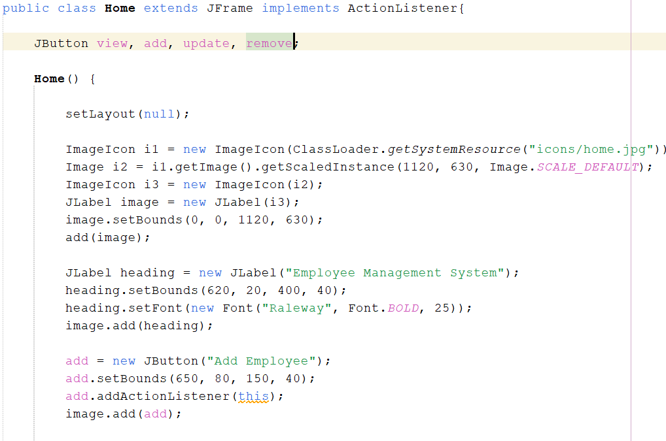

Figure 4: This is the login page where the admin can add, remove, view and update the database.

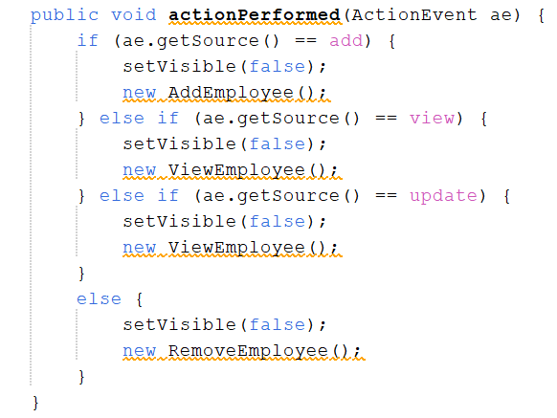

Figure 5: The logic behind the login page

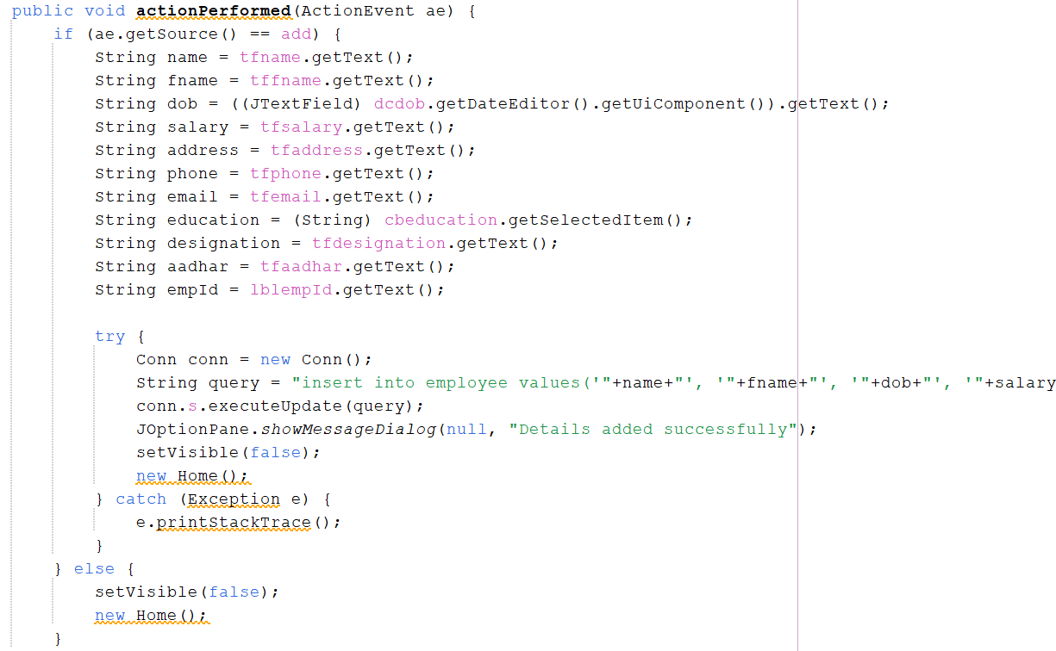

Figure 6: Logic behind the adding of employee into the system

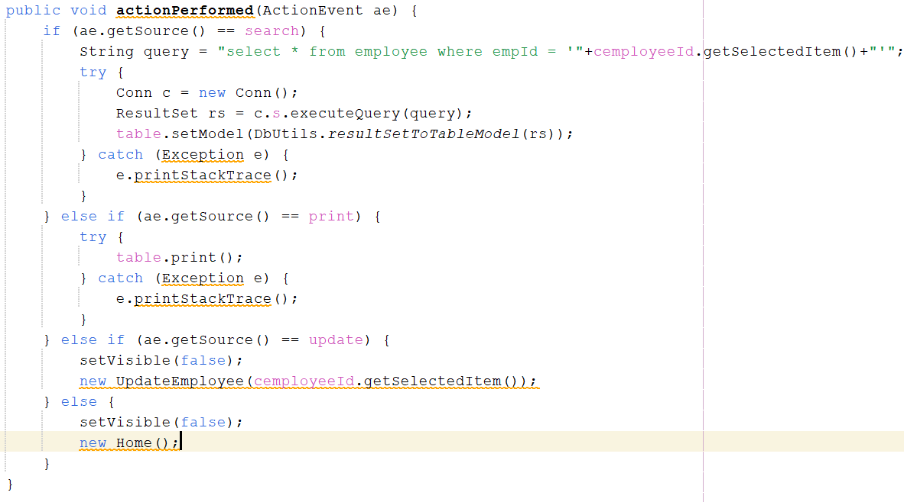

Figure 7: logic behind viewing the employee in the system

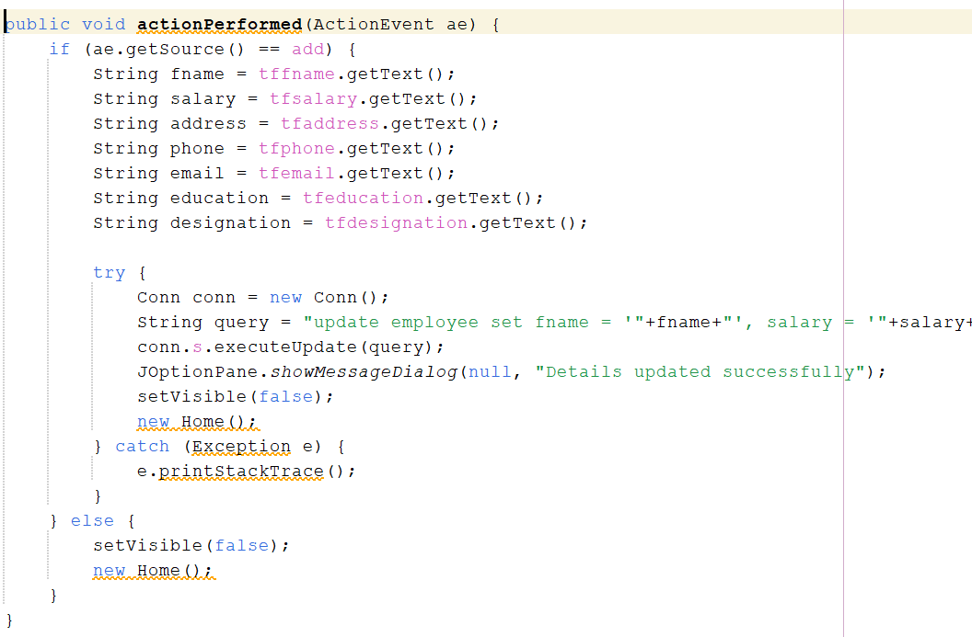

Figure 9: logic behind updating the system

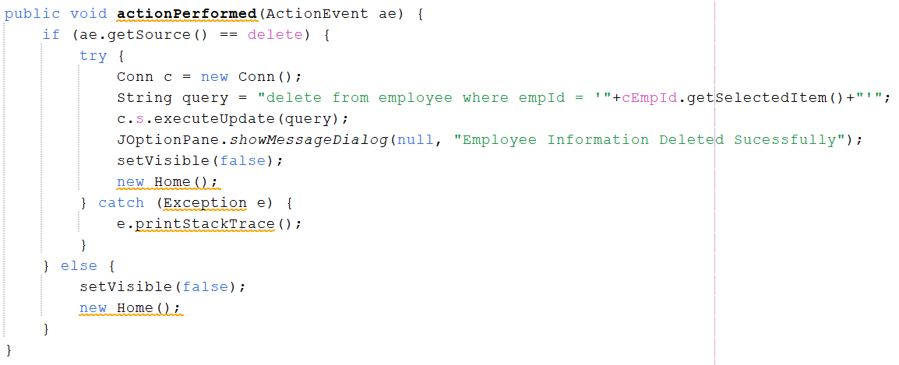

Figure 9: logic behind removing the employee from the system

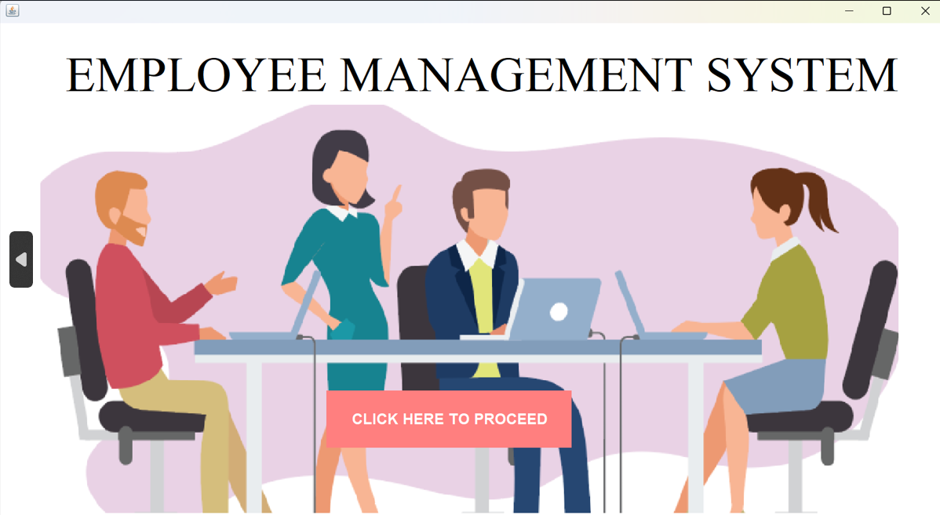 **Output:**

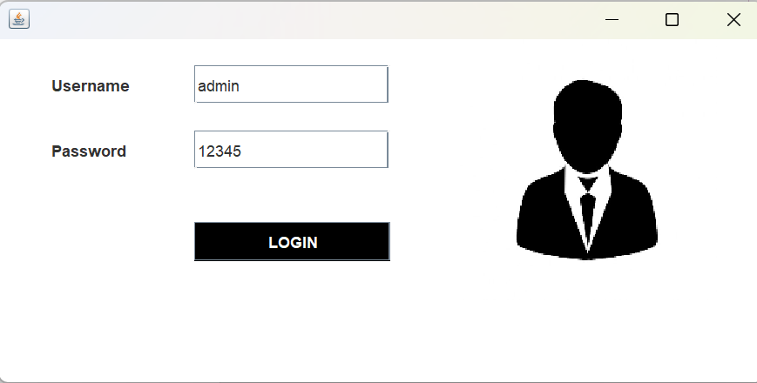Figure 10: This is the front page

Figure 11: Login page

###### Figure 12: Home page

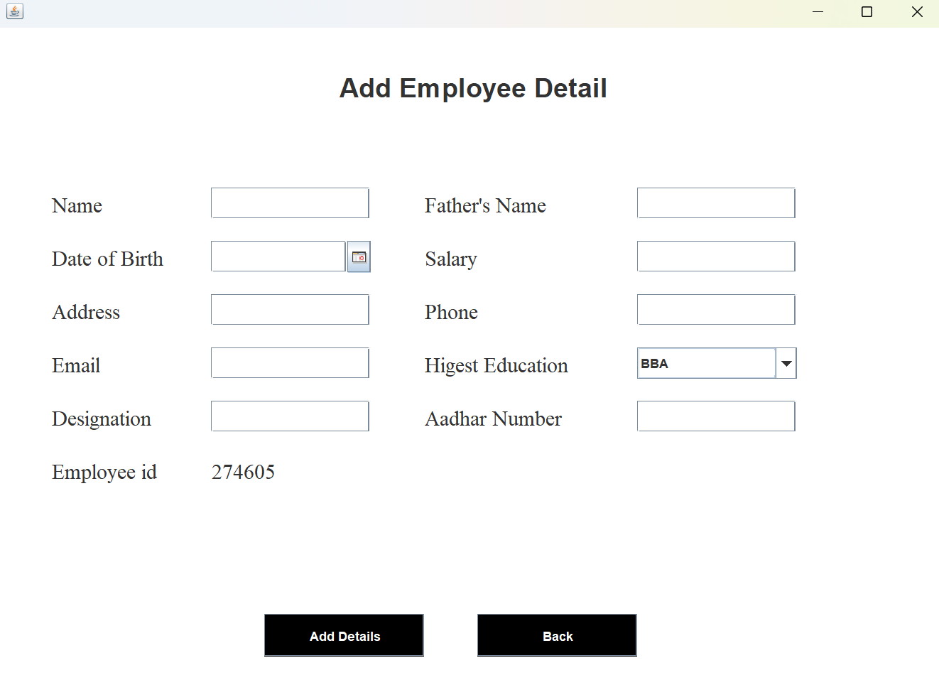

Figure 13: Add employee page

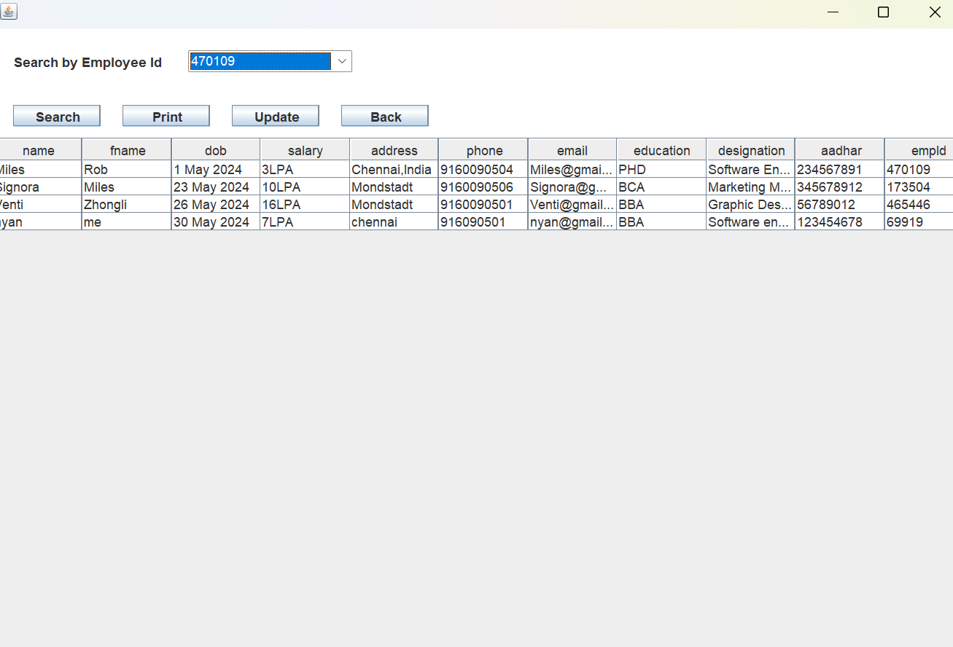

Figure 14: Update and View employee page

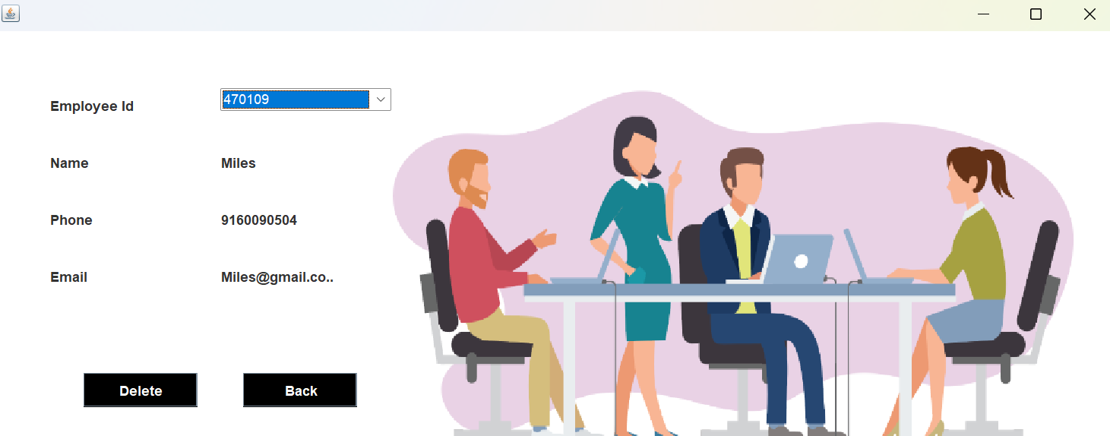

Figure 15: Remove employee page